B. TECH - COMPUTER SCIENCE AND ENGINEERING (V SEMESTER)
CST 303Concurrent and Parallel Programming Lab
Assignment : 3
- Implement Critical Section problem using semaphores with a monitor.

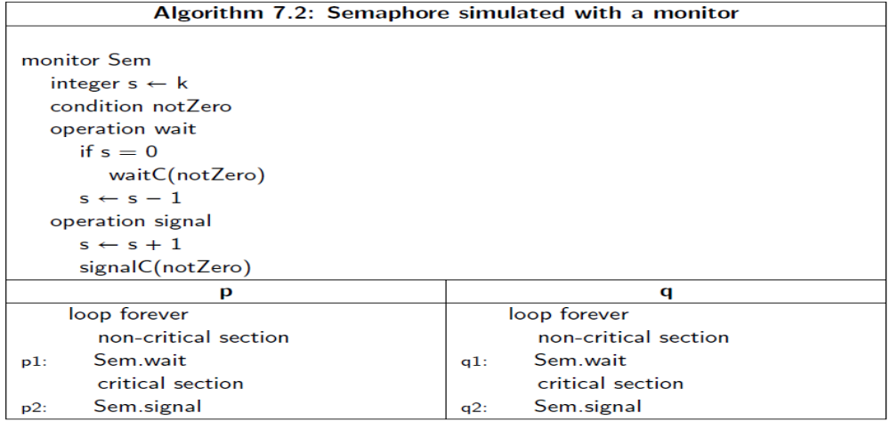
- Implement the solution of producer-consumer bounded buffer problem with a monitor.

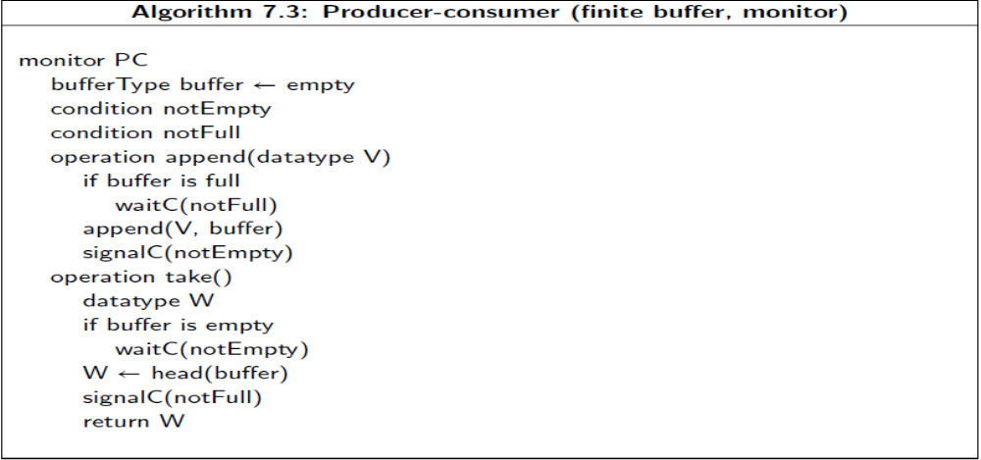
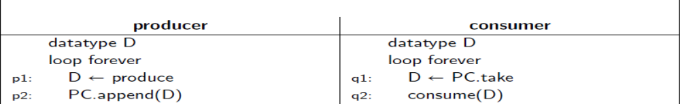

- Implement the solution of Readers and writers with a monitor.
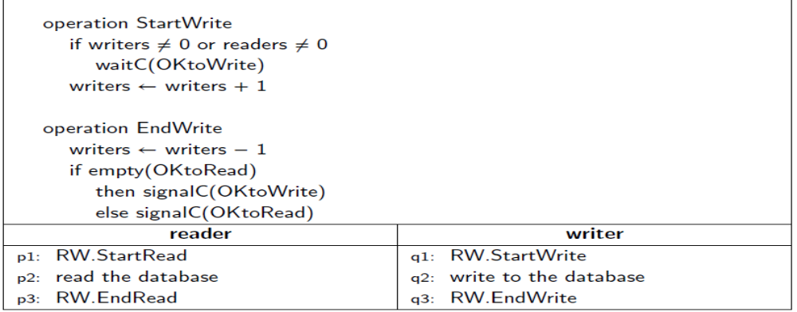
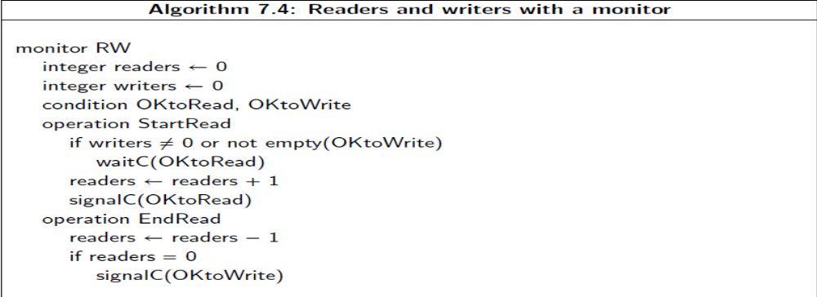

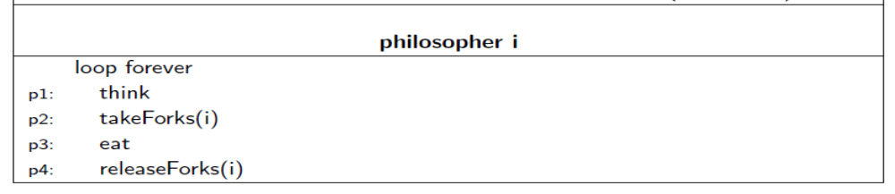
- Implement the solution of Dining philosophers with a monitor.